Internationally Recognized  UET Graduates Are Eligible to Work Globally as It Is Associated with Washington Accord. Programs Offered in Computer Science Are Recognized By Washington Accord.  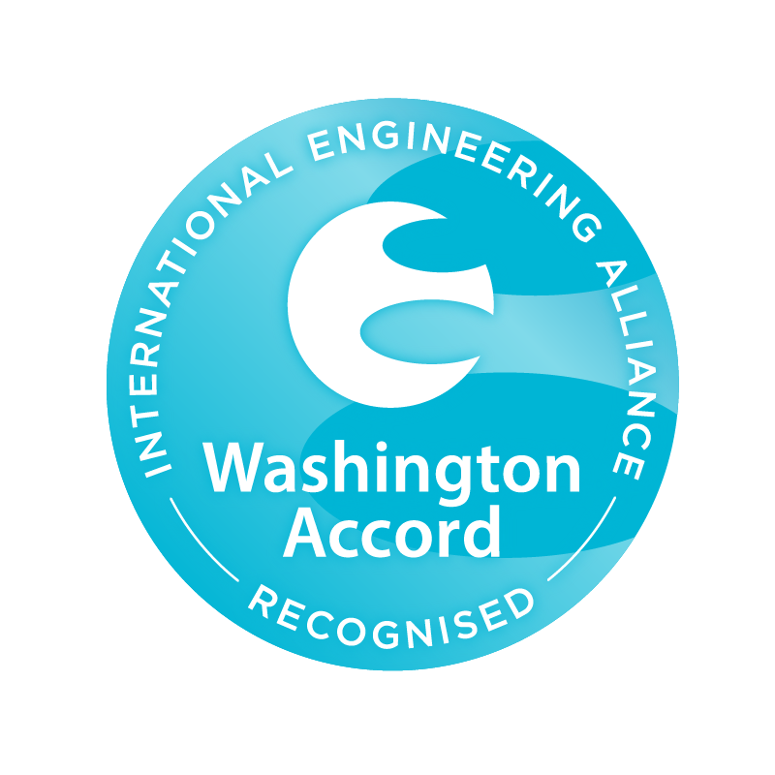  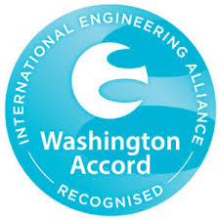 |  | 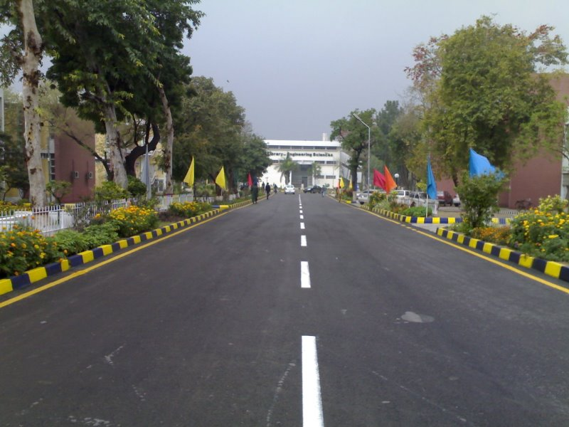  Visit us Online  Lms.uet.edu.pk  Cse.uet.edu.pk  Uet.acm@gmail.com |  |  | 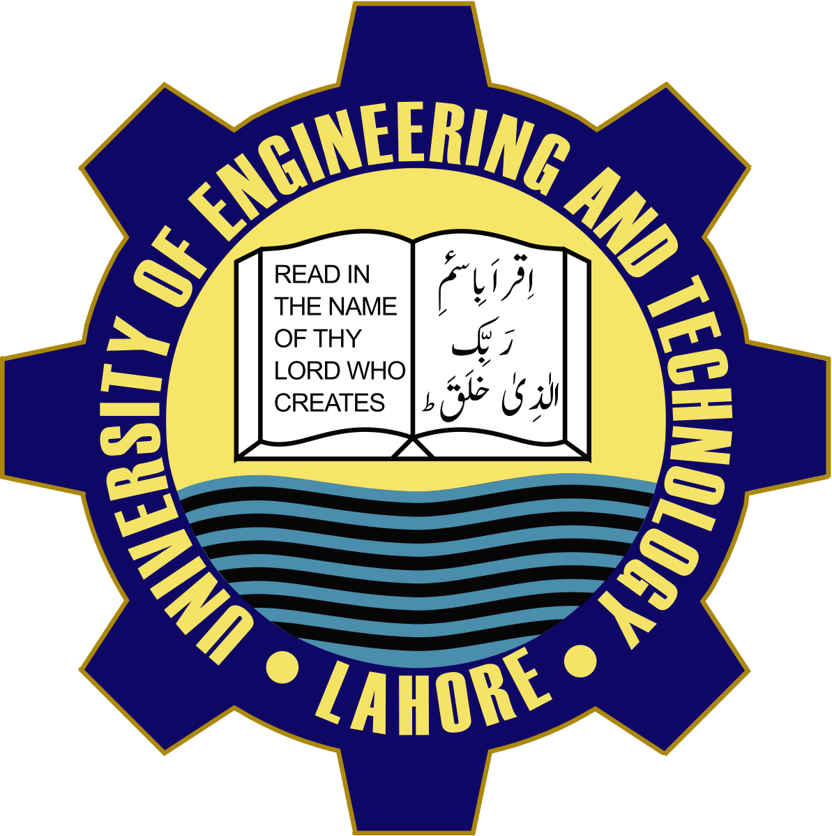  Department of Computer Science and  Engineering, UET Lahore.  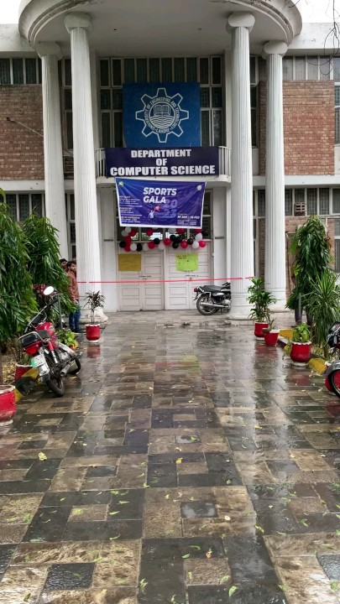

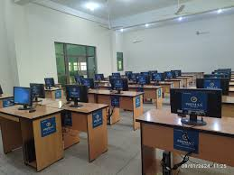  Courses Offered  - BSc. Computer Engineering  - BSc. Computer Science  - MSc. Computer Science  - MSc. Computer Engineering  Careers  - App Development  - Computer Networking  - Computer systems Administrators | “ Science is a way of thinking much more than it is a body of knowledge “  Carl Sagan  Technical Society  UET ACM is one of the celebrated scientific society which is actively participated in different events in collaboration with ICOSST (KICS)  - IEEE UET SOCIETY  - COMPUTER CLUB  - IET SOCIETY  COMPUTER FACILITIES  Computer cell is providing advanced internet services to all universities.  COMPUTER FACILITIES  Computer cell is providing advanced internet services to all universities. | Dean: Prof. Dr Aftab Sohail  Chairman: Prof. Dr  Muhammad Shahbaz  Contact Details  UET Admissions: 042-99029  216  Registrar: 042-99029227  Deputy Registrar: 042-99029  09  Assistant Registrar: 042-990  29417

